*Article*

**Empirical Study of the Use of Mobile Indonesian Sharia Bank in the MSME Digitalization Process**

1* Febrian Wahyu Wibowo, 2Rusny Istiqomah Sujono, 3Maishiva Avis Verdiana, 4Hesti Mardiana Harahap, and 5Indah Lestari

1 Alma Ata University, Indonesia

* Febrian Wahyu Wibowo: febrianwahyu@almaata.ac.id

|  |  |
| --- | --- |
|  | **ABSTRACT** |
|  | In the era of globalization, Micro, Small, and Medium Enterprises (MSMEs) face significant challenges in adopting digital technologies to remain competitive. This qualitative study explores the integration of the Bank Syariah Indonesia (BSI) Mobile application among MSMEs in the Yogyakarta Special Region, focusing on its impact on operational efficiency and the factors influencing its adoption. Through thematic analysis of in-depth interviews with seven purposively selected MSME owners, the study identifies the substantial potential of BSI Mobile in enhancing transaction management efficiency. However, challenges such as system integration and comprehensive training highlight the importance of technological compatibility and adequate support structures for successful technology adoption. Practical recommendations include enhancing technological integration, providing advanced user training, and regulatory support to facilitate broader technology adoption among MSMEs. The study contributes empirically by proposing a model for BSI Mobile application in MSME digitalization, suggesting avenues for future research and policy development to optimize digital transformation in small business contexts.  ***Keywords:*** MSMEs; digital technology; BSI Mobile; technology adoption; qualitative research |

**How to cite**: leave this part to the Editor

**INTRODUCTION**

Digital transformation is one of the main challenges faced by Micro, Small, and Medium Enterprises (MSMEs) in this era of globalization. Amid rapid technological developments, MSMEs must keep up with changes to remain relevant and competitive in the market (Hariyanti & Kristanti, 2024). The digitalization process offers various opportunities for MSMEs to increase productivity (Hendrawan et al., 2024), reduce operational costs (Kilay et al., 2022), and expand business networks (Hervé et al., 2021). Without the adoption of digital technology, MSMEs risk being left behind and losing significant market share (Bagale et al., 2021). Therefore, the digitalization of MSMEs is an urgent need to encourage the growth and sustainability of their businesses (Alfarizi et al., 2023).

Advances in information technology have opened various opportunities for MSMEs to increase operational efficiency. (Behl et al., 2022). With digital technology, MSMEs can automate their business processes, reduce manual errors, and speed up response times to market demand. (Koumas et al., 2021). Technology also allows MSMEs to utilize analytical data to identify market trends and customer needs. (Supriadi et al., 2023). Digitalization is not only about technology adoption but also about cultural transformation and business processes that are more efficient and innovative. Therefore, the ability of MSMEs to adapt to these changes will greatly determine their success in the future. One of the main challenges in digitalizing MSMEs is access to technology and financial support. This is where the role of financial institutions becomes very important. Bank Syariah Indonesia (BSI), one of the leading financial institutions in Indonesia, has taken the initiative to support the digitalization process of MSMEs through the development of the BSI Mobile application. (Kunaifi et al., 2022). This application is designed to provide various banking services that are easily accessible to MSMEs, including financial management, digital transactions, and access to other banking products. MSMEs can use BSI Mobile to manage their finances more efficiently and optimize their business operations.

Previous research by Nugroho & Nugraha (2020) Shows that using digital banking technology in the MSME sector can increase efficiency and expand the market. Other studies also highlight the benefits of technology adoption in various aspects of MSME businesses, including financial management, marketing, and operations (Lestari et al., 2022). However, research that specifically examines the impact of using banking applications such as BSI Mobile in the digitalization process of MSMEs is still very limited. This research seeks to fill this gap by exploring how BSI Mobile can support the digitalization of MSMEs and identifying the factors that influence its success.

BSI Mobile offers various features specifically designed to meet the needs of MSMEs. These features include digital payment services, real-time transaction monitoring, and easy access to various banking products such as loans and investments. This application also provides financial management features that help MSMEs manage cash flow, create budgets, and monitor economic performance. With BSI Mobile, MSMEs can run their business operations more efficiently and focus on developing their business (Abdulloh, 2023). However, although there are many potential benefits from using BSI Mobile, there is still limited research regarding the effectiveness and challenges MSMEs face in adopting this technology. The use of new technology is always accompanied by challenges, starting from varying levels of digital literacy among MSME players to the readiness of supporting infrastructure. Apart from that, external factors such as regulations and government policies can influence the adoption of digital technology by MSMEs. Therefore, comprehensive research is needed to identify the factors that affect the success of BSI Mobile implementation among MSMEs.

An empirical study is needed to identify the extent to which the use of BSI Mobile can support the digitalization of MSMEs, as well as the factors that influence the success of its implementation. This study will provide a clearer picture of the real benefits MSMEs feel from using BSI Mobile and the challenges they face. This research is important to bridge existing knowledge gaps and provide recommendations for developing more effective policies. Thus, it is hoped that the results of this research can encourage the adoption of digital technology by MSMEs and support inclusive economic growth in Indonesia.

This article is structured with the following structure: (1) Introduction, which discusses the background, research objectives, and importance of this study; (2) Literature Review, which reviews related literature regarding the digitalization of MSMEs and the use of digital banking technology; (2) Methodology which explains the methods used to collect and analyze data; (4) Results and Discussion that present research findings and analysis; (5) Conclusions and Suggestions which are a summary of the main research findings, practical implications, and recommendations for further research and policy.

**LITERATURE REVIEW**

**Digital Transformation**

Digital transformation is a significant phenomenon in the modern business world, where digital technology continues to be integrated into all operational aspects to increase efficiency and competitiveness. According to Hariyanti & Kristanti (2024)Digital transformation is not just about adopting new technology; it also involves fundamental changes in how businesses are run and creates significant added value.

In the Micro, Small, and Medium Enterprises (MSMEs) context, digital transformation is important in increasing responsiveness to rapid and dynamic market changes. According to Hendrawan et al., (2024)MSMEs that adopt digital technology tend to have higher productivity levels and can expand their market reach significantly (World Bank, 2019). MSMEs can expand their market share locally and internationally by utilizing digital platforms for marketing, sales, and operational management.

More than just technological tools, digital transformation also includes changes in mindset and business processes. According to Hervé et al., (2021)Successful SMEs in digital transformation can holistically integrate technology into their business strategy, change how they interact with customers, and increase efficiency in their supply chains.

Thus, digital transformation provides operational benefits and allows MSMEs to adapt to a rapidly changing business environment. This illustrates how important it is for MSMEs to adopt and utilize digital technology to survive and grow in an increasingly connected and digitally transformed era of globalization.

**Technological Innovation Theory**

The theory of technological innovation, first proposed by Everett M. Rogers in 1962 and updated in 2003, is an important framework for understanding the process of adopting new technology in a business context (Rogers & Rahim, 2021). This theory identifies key factors that influence the success of technology adoption, which can become the basis for strategy development and implementation in organizations.

Rogers emphasized that technology adoption is related not only to innovation's technical superiority but also to social and organizational factors that influence how technology is received and used. One of the main factors is organizational readiness, which includes management's ability to manage change and adapt to new technology. Organizations with flexible management systems and open to innovation tend to be more successful in adopting new technology.

Technological competence is also a crucial aspect of this theory. This includes the technical expertise of the staff who will use the technology and the technological infrastructure available within the organization. The success of technology adoption depends not only on the existence of the technology itself but also on the organization's ability to understand, implement, and integrate the technology into its business processes.

External support is also an important factor in this theory. Rogers highlighted that government policies that support technological innovation and technical assistance from technology providers or other institutions can facilitate smoother technology adoption. This external support can take the form of financial incentives, technical training, or supporting infrastructure, which can help overcome barriers to adopting new technologies.

Technological innovation theory provides a comprehensive view of how organizations can utilize and manage technological change to improve their performance and competitiveness. Organizations can design more effective strategies for integrating technological innovation into their operations by understanding the factors that influence technology adoption.

**Diffusion of Innovation Theory**

The diffusion of innovation theory, also developed by Everett M. Rogers, provides a valuable framework for understanding how new technologies, such as the BSI Mobile application, are adopted and used in the context of Micro, Small, and Medium Enterprises (MSMEs). This theory identifies five main factors that influence the innovation diffusion process (Rogers & Rahim, 2021):

1. Relative Advantage

This factor assesses how much innovation is better than previous methods or technologies. In the MSME context, BSI Mobile must be able to offer clear and significant benefits, such as easy access to financial services, to convince potential users of its advantages.

1. Compatibility

Compatibility refers to the extent to which the innovation is compatible with the values, needs, and practices already existing within the MSME environment. For example, BSI Mobile must be easy to integrate with existing business processes and meet the specific needs of MSMEs without causing excessive disruption.

1. Complexity

The level of difficulty in understanding and using innovation is an important factor. The simpler and more intuitive BSI Mobile is to use, the more likely MSMEs will accept and adopt it. This reduces barriers to the adoption of complex technologies.

1. Ability is tested

Piloting or trialing innovations before full adoption allows MSMEs to understand the benefits provided before making a full investment decision. BSI Mobile needs to offer MSMEs the opportunity to test its features and functionality before engaging in full implementation.

1. Visibility

The clarity and visibility of the results of using an innovation greatly influence adoption. In the context of BSI Mobile, positive results from using this application, such as increased operational efficiency and accessibility of financial services, must be visible and measurable by MSMEs.

By considering these factors, MSMEs can better understand the challenges and opportunities in adopting BSI Mobile or other technologies to support their digital transformation. Successful implementation requires a deep understanding of how the innovation can meet the specific needs of MSMEs and provide significant added value in improving their performance and competitiveness.

**Change Management**

The change management theory developed by Kurt Lewin (1951) provides an important insight into the context of using BSI Mobile for the digital transformation of MSMEs. Lewin described that change in organizations goes through three main stages: unfreezing, changing, and refreezing (Rosdiana & Aslami, 2022).

Increase competitiveness

Unfreezing

Changing

Refreezing

1. Understand and manage digital transformation with BSI Mobile

2. Identify challenges and opportunities

3. Reduce resistance to change.

Adaptation to changes in digital technology

BSI Mobile

Achieve stability of business operations

Figure 1

Change in organizations

First, the unfreezing stage involves recognizing that change is necessary and preparing to abandon old ways that may be ineffective. In the context of MSMEs, this stage includes awareness of the importance of adopting new technology, such as BSI Mobile, to increase efficiency and competitiveness.

Second, the changing stage is when the organization begins to adopt new technology and adapt to the changes. This includes staff training processes, technology integration in business processes, and adaptation to changes brought by digital technology.

Third, the refreezing stage occurs when new technology, such as BSI Mobile, has been fully integrated into the operational routines of MSMEs. At this stage, technology becomes part of daily routines and helps achieve stability in business operations.

Applying this theory helps MSMEs systematically understand and manage changes induced by BSI Mobile adoption. By understanding these stages, MSMEs can identify challenges and opportunities in adopting new technology and minimize resistance to change. Thus, Lewin's change management theory becomes a strong foundation for understanding and managing digital transformation in the context of MSMEs through technology such as BSI Mobile.

**MSME Resources and Development**

The resource theory (Resource-Based View) developed by Barney presents the view that an organization's competitive advantage depends on the unique resources and capabilities it has (Barney et al., 2021). In the context of Micro, Small, and Medium Enterprises (MSMEs), these resources include financial assets, skilled human resources, technological capabilities, and strong business networks. Competitive advantage can be achieved if MSMEs can optimize the use of these resources to adopt digital technology. Using applications such as BSI Mobile can be a strategy to improve MSMEs' technological and operational capabilities to compete more effectively in an increasingly digital market.

Furthermore, the MSME development theory put forward by Tambunan (2009) emphasizes the importance of external support in supporting the growth and development of MSMEs. This support includes government policies supporting the MSME sector, access to affordable financing, and adequate infrastructure to support digitalization. In today's digital era, external support is increasingly crucial in ensuring that MSMEs have sufficient access to the technology and resources needed to adopt digital innovations successfully. Applications such as BSI Mobile, which Bank Syariah Indonesia supports, are important tools that can help facilitate the development of MSMEs in facing the challenges and opportunities in this digital era.

**Previous Study**

One of the main benefits of mobile banking is increasing access to financial services (Adhitya & Sembel, 2020; Ananda et al., 2023). MSMEs can conduct banking transactions anytime and anywhere without visiting a physical bank (Wardhani et al., 2023). This is very important for MSMEs, which often operate with limited resources and require time and cost efficiency. These time and cost savings can be reallocated to more productive business activities, thereby increasing operational efficiency and operating profits (Alumasa & Muathe, 2021; Saifurrahman & Kassim, 2024). Banking applications that can be accessed via smartphone help MSMEs in rural areas access banking services without going to a bank branch that may be far from their location (Nalane & Sekantsi, 2020). This helps reduce the gap in access to financial services between urban and rural areas. Financial support and access to technology significantly positively impact the digitalization of MSMEs (Naradda Gamage et al., 2020). Some of the agreements found in these studies include that financial support helps MSMEs in purchasing the hardware and software needed for digitalization (Arie & Fikry, 2021) and running digitalization programs, such as employee training and online marketing (Subkhan et al., 2024). Access to technology allows MSMEs to utilize digital platforms and carry out digitalization programs more easily and efficiently. For example, a study by (2023) shows that adopting digital technology positively correlates with increasing MSME profits. A case study by (2023) and Klein & Todesco shows how digitalization helps MSMEs to survive and develop during the pandemic, emphasizing the importance of technological adaptation for MSMEs in the digital era. Gunawan et al. (2023) examine how integrating digital technology can improve MSME financial governance. Ismanto et al. (2023) discuss how fintech, including mobile banking applications, can improve MSMEs' financial access and performance. BSI Mobile provides financial solutions that can be accessed easily (Arif et al., 2022), including working capital loans and insurance services (Masitoh et al., 2022), which can help MSMEs accelerate their digitalization process. Research by Dewi (2023) also examines how integrating digital technology can improve MSME financial governance. BSI Mobile provides features such as fund transfers, bill payments, and integrated financial reporting (Febriani et al., 2021), which can help MSMEs manage their finances more efficiently. The use of mobile banking allows MSMEs to monitor cash flow (Adiandari, 2022), control expenses (Ahmed & Sur, 2021), and make better business decisions based on accurate data (Tengeh & Gahapa Talom, 2020). The security of digital transactions offered by mobile banking is also an important factor in supporting the digitalization of MSMEs (Meher et al., 2021). Trust in transaction security is key in adopting digital technology, especially in financial transactions (NOREEN et al., 2021). Furthermore, mobile banking can support financial inclusion for MSMEs in rural and remote areas (Okello Candiya Bongomin & Munene, 2021). The study by Laurentinus et al. (2021) discusses the government's program to support the digitalization of MSMEs in the retail sector through the RISTEK-BRIN grant program.

These studies show that using mobile banking such as BSI Mobile can provide various real benefits for MSMEs in their digitalization process. From easier and faster access to banking services, support for financial inclusion, and transaction security to increased efficiency and productivity, mobile banking plays an important role in helping MSMEs adapt to the digital era. Thus, the adoption of mobile banking by MSMEs not only drives their digital transformation but also strengthens the foundation of Indonesia's digital economy.

Although much research has been conducted, several unresolved questions remain related to the digitalization of MSMEs and financial support and access to technology. Some questions that still exist include the extent to which the use of BSI Mobile can support the digitalization of MSMEs and the factors that influence the success of its implementation, which are still interesting research areas. The real benefits MSMEs feel from using BSI Mobile, as well as the challenges they face in this process, are also important aspects that need to be explored further.

**Research Framework**

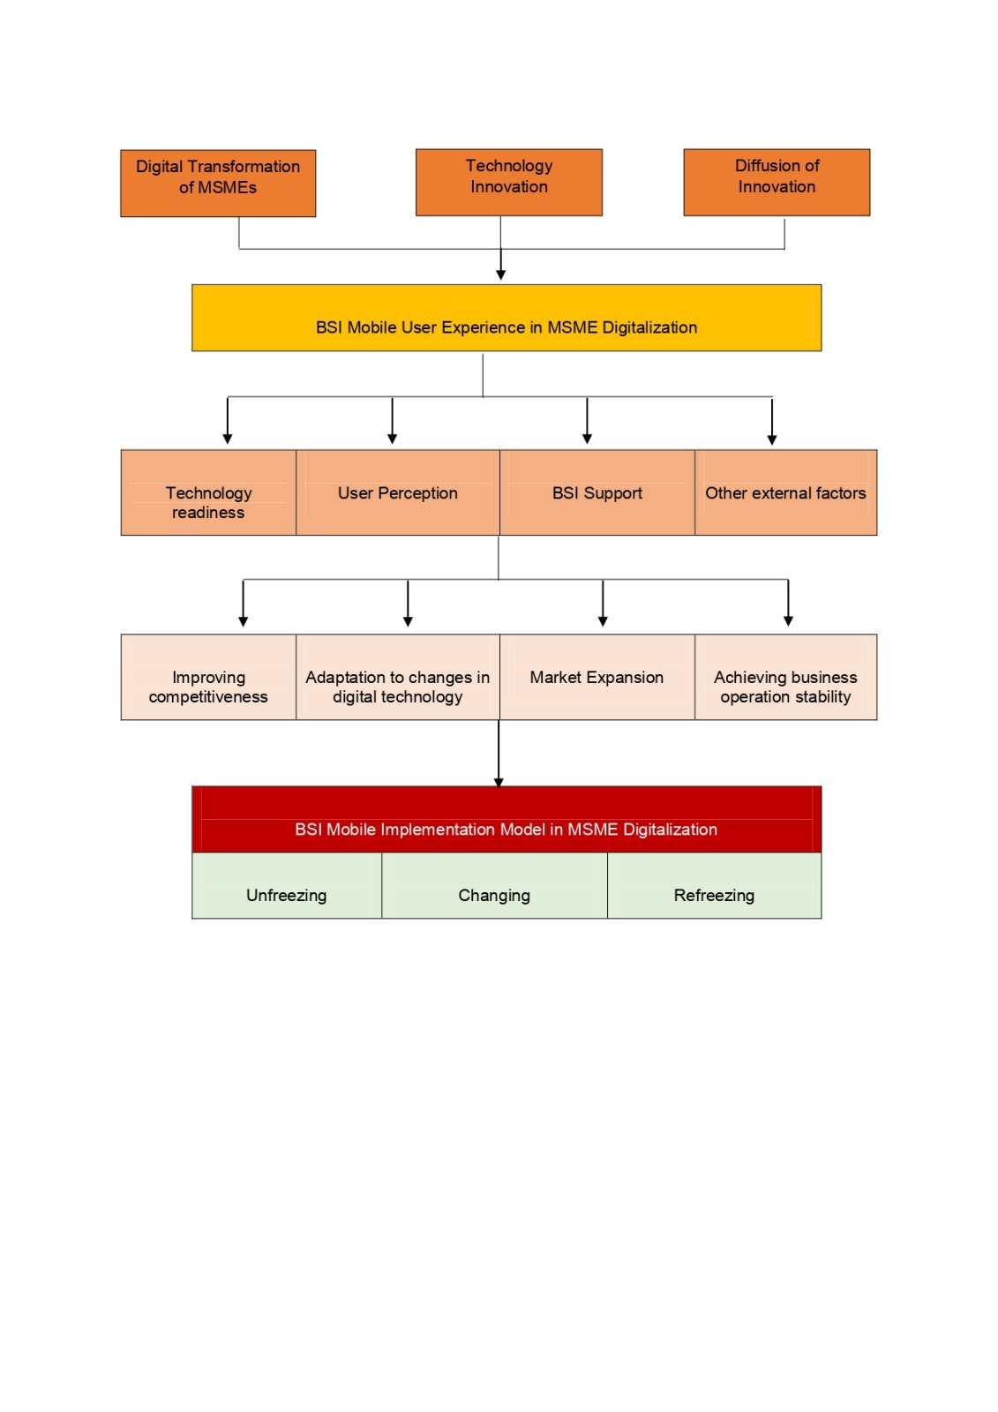

**Figure 2**

**Research Framework (Source, 2022)**

**METHODOLOGY**

This research method is qualitative research using a thematic approach. The research informants consisted of 7 MSME actors in the Special Region of Yogyakarta who were selected purposively based on inclusion criteria, namely MSME actors who had used BSI Mobile for at least six months and had a business that had been running for at least one year. Research procedures were carried out through in-depth interviews with informants and direct observation. This research refers to four main aspects: (1) Experience of using BSI Mobile; (2) Factors influencing the adoption and use of BSI Mobile; (3) The expected impact of using BSI Mobile. Next, from the conclusions of the interview results, the researcher will present a model for implementing BSI Mobile in digitalizing MSMEs. Data analysis was done using the Narrative Analysis method to explore findings based on themes from interviews and observations.

**RESULT AND DISCUSSION**

**Informant Demographic Profile**

The informants come from various business sectors, including trade (40%), services (30%), and manufacturing (30%). They represent a broad spectrum of small and medium businesses in Yogyakarta, ranging from retail shops, cafes, workshops, and handicraft producers. This diversity provides a comprehensive picture of how BSI Mobile is adopted and used in various business contexts.

In terms of education, these MSME actors have varied backgrounds, ranging from high school graduates (50%) to bachelor's degrees (50%), which shows different levels of literacy and technological competence. In addition, informants were also divided into various age groups: 18-25 years (20%), 26-35 years (40%), 36-45 years (25%), and over 45 years (15%).

The diversity of business sectors and educational backgrounds of MSME players aligns with the diffusion of innovation theory put forward by Rogers (2003). This theory states that various factors, including relative advantage, compatibility, and complexity, influence the adoption of new technology. In this context, the trade sector, which dominates with 40% of business actors, reflects the need for digital solutions to improve operational efficiency and transaction management. Meanwhile, the service and manufacturing sectors accounted for 30%, indicating that BSI Mobile is also used to improve customer service and production management.

The varied educational backgrounds of MSME players also indicate that the level of digital literacy plays an important role in technology adoption. Bachelor graduates, who account for 50% of the informants, likely have higher technological competence, making adopting and utilizing BSI Mobile features easier. In contrast, high school graduates, who also make up 50%, may need more support and training to achieve the same level of adoption.

The age group also influences technology adoption. The 26-35-year-old age group, which accounts for 40% of the informants, may be more adaptive to new technology than the age group over 45, which is only 15%. The 18-25-year-old (20%) and 36-45-year-old (25%) age groups also show variations in their acceptance and use of technology, with younger generations tending to be quicker in adopting new technology.

Overall, this demographic profile provides in-depth insight into BSI Mobile's influence on the digitalization of MSMEs in Yogyakarta and supports an understanding of how various factors such as business sector, educational background, and age influence technology adoption in small and medium businesses.

**Experience using BSI Mobil**

Informants from various business sectors, such as trade, services, and manufacturing, gave varied descriptions of their experiences using BSI Mobile. Although this application is generally found to be very helpful in transaction management and financial reporting, some users experience challenges that reflect gaps in theories related to technology adoption.

One of the interview results shows that the BSI Mobile application makes it easy to manage daily finances, but a manufacturing entrepreneur complained about the inability to integrate transaction data directly into their accounting system.

*"...We often experience difficulties because BSI Mobile cannot automatically synchronize transaction data with our accounting system. This causes us to have to perform double data entry, which is inefficient and can lead to errors..." - IM1*

This refers to the concept of compatibility in the diffusion of innovation theory (Rogers & Rahim, 2021), where less-than-perfect integration with existing infrastructure can hinder the adoption of new technology. The pattern of findings from other interviews highlights the need for better technical support, consistent with theories of technological innovation that emphasize the importance of technical support in increasing technology adoption. (Barney et al., 2021). A service business owner stated:

*"... Although this application is easy for daily transactions, I feel more training is needed to utilize advanced features such as more complex financial reports. More in-depth training support could be very helpful in maximizing the benefits of BSI Mobile... ” – IB1*

This gap between expectations and user experience reflects common challenges in adopting new technology in business environments, where compatibility with existing infrastructure and adequate training support are often the keys to success (Rogers & Rahim, 2021). Overall, although BSI Mobile provides many benefits in improving operational efficiency and adapting to an increasingly digital business environment, there is still room for improvement in terms of system integration, training support, and technical reliability to meet the full potential of this application, as found in theory- technology adoption theory and previous research.

**Factors influencing the adoption and use of BSI Mobile**

Factors influencing the adoption and use of BSI Mobile can be seen from various points of view of users from different business sectors. BSI Mobile was found to provide significant benefits in transaction management and financial reporting. However, several factors influence the optimal use of this application.

One factor that emerged from the interview results was technology compatibility. An MSME owner in the trade sector said:

"...We faced challenges integrating BSI Mobile with our existing management information system. While the app was great for daily transactions, we still had to do some manual data entry into our existing system..." – ID1

This illustrates the gap with technology adoption theories as explained by (Rogers & Rahim, 2021), where successful adoption depends on the fit or compatibility of the new technology with existing infrastructure. Apart from that, training support factors also play a crucial role. A manufacturing business owner stated:

"...Training support to understand the advanced features of BSI Mobile is critical. We need more training to optimize more complex financial reports..." ¬IM2

The above findings are based on technological innovation theories, indicating that adequate training support can increase the level of adoption and utilization of new technology in the business environment. (Barney et al., 2021). In conclusion, although BSI Mobile has great potential to improve operational efficiency and adapt to an increasingly digital business environment, factors like compatibility with existing infrastructure and adequate training support still need further attention. Improvements in system integration and better training support can help maximize the benefits of these applications, which align with technology adoption theories and previous research.

**Expected impact of using BSI Mobile**

This application is generally expected to increase efficiency in transaction management and financial reports. However, several aspects reflect challenges and gaps with related theories. One of the expected impacts is improved operational efficiency. A business actor from the trade sector stated:

*"...BSI Mobile is very helpful in managing our daily transactions. We can make bill payments and fund transfers more quickly and easily..." – ID2*

This aligns with technological innovation theories, emphasizing that adopting new technology can increase operational efficiency (Rogers & Rahim, 2021). However, challenges regarding technology integration also need to be overcome. A service entrepreneur stated:

*"...We had difficulty integrating BSI Mobile with our existing financial management system. This resulted in us having to do some double data entry, which was time-consuming and error-prone..." – IB1*

The emphasis on seamless systems integration in innovation diffusion theory suggests that compatibility with existing infrastructure is a key factor in successfully adopting new technologies (Barney et al., 2021). Another expected impact is increased accessibility of financial information and real-time monitoring. Technology adoption theories show that the accessibility and usability of applications such as BSI Mobile can increase transparency and control in company financial management.

Although BSI Mobile has great potential to positively impact operational efficiency and accessibility of financial information, challenges related to system integration and the need for better technical support still need to be addressed. According to technology adoption theories and previous research findings, improvements in these areas can help maximize the benefits of these applications.

**BSI Mobile implementation model in digitalizing MSMEs**

The model for implementing BSI Mobile in digitalizing MSMEs is a proposal based on research results on technology adoption in the small and medium business sector. By integrating BSI Mobile, MSMEs can be expected to increase operational efficiency through more effective daily transaction management, structured financial management, and easier access to banking services. The research results show that these applications facilitate daily business processes and expand the scope of MSMEs in the digital ecosystem, enabling them to compete better in an increasingly globally connected market. In this context, this model proposes an integrated approach to support the growth and sustainability of MSMEs through technology optimization and strategic adaptation to rapid digital developments.

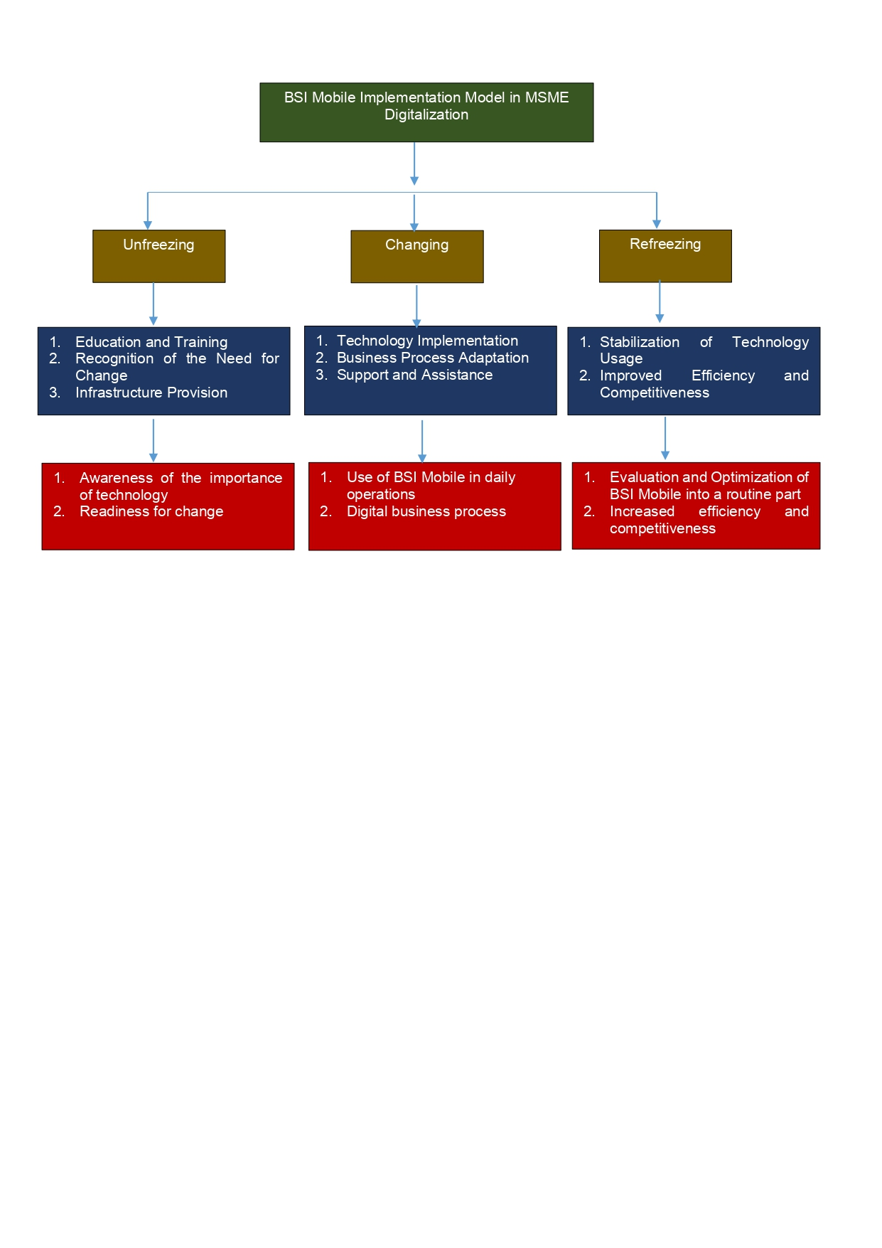

Figure 3

BSI Mobile implementation model in digitalizing MSMEs

The BSI Mobile application model in digitalizing MSMEs in detail includes three main aspects as follows:

1. Unfreezing Stage

The Unfreezing stage in the BSI Mobile implementation model for digitalizing MSMEs begins with education and training organized by BSI and the local government. This training program aims to increase MSME players' understanding of the benefits of digitalization, how to use the BSI Mobile application, and how technology can help them manage their business more effectively. These educational sessions teach MSMEs about various application features, functions, and strategies for integrating digital technology into their daily operations. This approach ensures that MSMEs have sufficient knowledge to use technology optimally and overcome challenges that may arise during the adoption process.

Next, the unfreezing stage also involves recognizing the need for change and providing the necessary infrastructure. At this stage, MSME players begin to realize the importance of digital technology in increasing the efficiency and competitiveness of their business. This realization motivated them to switch from traditional to digital methods. BSI provides the necessary infrastructure to support this transition, such as hardware (smartphones or tablets) and internet access. This infrastructure support ensures that MSMEs have adequate tools to access and use BSI Mobile effectively to run their businesses more smoothly and efficiently in the digital era.

1. Changing Stage

The Changing stage in the BSI Mobile implementation model for digitalizing MSMEs involves concrete technology implementation steps. MSME players integrate BSI Mobile into their daily business operations at this stage. This implementation includes using BSI Mobile for various banking transactions, digital payments, financial management, and access to other banking services. MSME players are also taking advantage of the BSI Mobile application's features, such as inventory management, sales tracking, and business data analysis, to make better decisions and increase operational efficiency. This move marks a shift from traditional methods to digital technology in every aspect of their business.

Besides implementing technology, the changing stage also involves adapting business processes and providing ongoing support and assistance from BSI. MSME players need to change and adapt their business processes to suit the use of digital technology. For example, they may have to adjust how they manage inventory, track sales, and analyze business data using BSI Mobile application features. BSI provides technical support and ongoing assistance to ensure the adaptation process runs smoothly. This includes assisting in overcoming technical obstacles that may arise and giving advice on maximizing the application's use. With this support, MSME players can optimize the use of BSI Mobile and achieve the full benefits of digitalization in their business operations.

1. Refreezing Stage

The Refreezing stage in the BSI Mobile implementation model for digitalizing MSMEs is where technology has become a routine part of business operations. At this stage, MSME players are accustomed to using the BSI Mobile application and consistently utilize the various features available. The stabilization of the use of this technology shows that MSMEs are comfortable and proficient in using applications for banking transactions, financial management, and other digital services. Digitalization processes have become integral to their business, enabling more effective and efficient operations.

With full adoption of BSI Mobile, MSMEs experience various significant benefits, including increased operational efficiency, expanded market reach, and increased competitiveness. Apart from that, the refreezing stage also involves a process of evaluating and optimizing the use of technology. MSME players and BSI regularly assess the use of applications to identify areas that can be improved. This includes analyzing how technology is used in daily activities and looking for ways to optimize application functionality further to achieve greater business benefits. In this way, MSMEs can continue to adapt and develop in the digital era, utilizing technology to achieve long-term success.

With this implementation model, it is hoped that MSMEs can maximize the benefits of digitalization through the use of BSI Mobile, ultimately increasing their competitiveness in an increasingly competitive market.

**CONCLUSION AND RECOMMENDATION**

Based on research results, the integration of BSI Mobile in MSMEs shows great potential in increasing operational efficiency through more effective transaction management. However, challenges regarding system integration with existing infrastructure and more in-depth training still need to be addressed. These findings underscore the importance of technology compatibility and adequate training support in ensuring successful technology adoption among MSMEs. Practical recommendations include increasing technology integration with existing systems, providing further training for users, and regulatory support to facilitate wider adoption of this technology among MSMEs. In addition, follow-up studies are expected to develop more effective strategies to overcome these obstacles and evaluate the long-term impact of digitalization using BSI Mobile in the context of small and medium businesses.

**REFERENCES**

Abdulloh, M. (2023). Digital Transformation of Bank Syariah Indonesia Services and Its Impact on Financial Inclusion. *Invest Journal of Sharia & Economic Law*, *3*(2), 224–235.

Adhitya, A., & Sembel, H. R. (2020). The impacts of mobile banking technology adoption on big banks' financial performance and stock performance in Indonesia. *Language*, *14*(148p), 30cm.

Adiandari, A. M. (2022). Financial performance innovation since digital technology entered Indonesian MSMEs. *International Journal for Applied Information Management*, *2*(1), 50–58.

Ahmed, S., & Sur, S. (2021). The use pattern of digital banking services changed by Indian rural MSMEs during demonetization and Covid-19 pandemic-related restrictions. *Vilakshan-XIMB Journal of Management*, *20*(1), 166–192.

Alfarizi, M., Widiastuti, T., & Ngatindriatun. (2023). Exploration of Technological Challenges and Public Economic Trends Phenomenon in the Sustainable Performance of Indonesian Digital MSMEs on Industrial Era 4.0. *Journal of Industrial Integration and Management*, 1–32.

Alumasa, S., & Muathe, S. (2021). Mobile Credit and Performance: Experience and Lessons from Micro and Small Enterprises in Kenya. *Journal of Applied Finance & Banking*, *11*(4), 135–161.

Ananda, M. O., Annuar, S. N. S., Adam, A. A., & Sharkawi, S. (2023). The pivotal role of cashless system adoption among micro, small, and medium enterprises (MSMEs) in Malaysia: The challenges and opportunities. *Economics and Law*, *28*(3), 35–43.

Arie, H. A., & Fikry, A. M. (2021). Development of synergistic between digitalization MSMEs and digital society in Indonesia. *Ho Chi Minh City Open University Journal of Science-Economics and Business Administration*, *11*(2), 18–30.

Arif, Z., Zahira, H., & Zen, M. (2022). Optimizing the Use of Mobile Banking Service Systems in Attracting Customer Interest at PT Bank Syariah Indonesia. *ITQAN: Journal of Islamic Economics, Management, and Finance*, *1*(2), 53–59.

Bagale, G. S., Vandadi, V. R., Singh, D., Sharma, D. K., Garlapati, D. V. K., Bommisetti, R. K., Gupta, R. K., Setsiawan, R., Subramaniyaswamy, V., & Sengan, S. (2021). Small and medium-sized enterprises’ contribution to digital technology. *Annals of Operations Research*, 1–24.

Barney, J. B., Ketchen Jr, D. J., & Wright, M. (2021). Resource-based theory and the value creation framework. *Journal of Management*, *47*(7), 1936–1955.

Behl, A., Gaur, J., Pereira, V., Yadav, R., & Laker, B. (2022). Role of big data analytics capabilities to improve sustainable competitive advantage of MSME service firms during COVID-19–A multi-theoretical approach. *Journal of Business Research*, *148*, 378–389.

Febriani, A., Iswandi, N., & Tiara, S. A. (2021). Quick Response Code Indonesian Standard System on the Mobile Banking Application of Mandiri Sharia Bank. *FITRAH: Jurnal Kajian Ilmu-Ilmu Keislaman*, *7*(2), 285–310.

Gunawan, A., Jufrizen, J., & Pulungan, D. R. (2023). Improving MSME performance through financial literacy, financial technology, and financial inclusion. *International Journal of Applied Economics, Finance and Accounting*, *15*(1), 39–52.

Hariyanti, S., & Kristanti, D. (2024). Digital Transformation in MSMEs: an Overview of Challenges and Opportunities in Adopting Digital Technology. *Jurnal Manajemen Bisnis, Akuntansi Dan Keuangan*, *3*(1), 37–46.

Hendrawan, S. A., Chatra, A., Iman, N., Hidayatullah, S., & Suprayitno, D. (2024). Digital Transformation in MSMEs: Challenges and Opportunities in Technology Management. *Jurnal Informasi Dan Teknologi*, 141–149.

Hervé, A., Schmitt, C., & Baldegger, R. (2021). Digitalization, entrepreneurial orientation & internationalization of micro-, small-, and medium-sized enterprises. *Technology Innovation Management Review*.

Ismanto, H., Wibowo, P. A., & Shofwatin, T. D. (2023). Bank stability and fintech impact on credit performance and credit accessibility. *Banks and Bank Systems*, *18*, 105–115.

Kilay, A. L., Simamora, B. H., & Putra, D. P. (2022). The influence of e-payment and e-commerce services on supply chain performance: Implications of open innovation and solutions for the digitalization of micro, small, and medium enterprises (MSMEs) in Indonesia. *Journal of Open Innovation: Technology, Market, and Complexity*, *8*(3), 119.

Klein, V. B., & Todesco, J. L. (2021). COVID‐19 crisis and SMEs responses: The role of digital transformation. *Knowledge and Process Management*, *28*(2), 117–133.

Koumas, M., Dossou, P.-E., & Didier, J.-Y. (2021). Digital transformation of small and medium sized enterprises production manufacturing. *Journal of Software Engineering and Applications*, *14*(12), 607–630.

Kunaifi, A., Sad, A. A., & Mawardi, A. (2022). Opportunities Analysis of Indonesian Sharia Bank (BSI) Become Top 5 Bank in Indonesia Based on Asset Strength and Vision Mission. *Majapahit Journal of Islamic Finance and Management*, *2*(1), 1–22.

Kurniawan, -, Maulana, A., & Iskandar, Y. (2023). The effect of technology adaptation and government financial support on sustainable performance of MSMEs during the COVID-19 pandemic. *Cogent Business & Management*, *10*(1), 2177400.

Lestari, E. D., Hamid, N. A., Rizkalla, N., Purnamaningsih, P., & Urus, S. B. T. (2022). The Effect of Financial Literacy, Cost of Technology Adoption, Technology Perceived Usefulness, and Government Support on MSMEs’ Business Resilience. *Global Journal of Business Social Sciences Review (GATR-GJBSSR)*, *10*(3).

Masitoh, N., Sudaryanti, D. S., Munawar, A. H., & Fahmi, A. S. R. (2022). Analysis of the Mobile Banking Service Model at Bank Syariah Indonesia from the Sharia Concept Review. *Prosiding SEMINAR NASIONAL & CALL FOR PAPER Fakultas Ekonomi*, *1*, 10–22.

Meher, B. K., Hawaldar, I. T., Mohapatra, L., Spulbar, C., Birau, R., & Rebegea, C. (2021). The impact of digital banking on the growth of Micro, Small and Medium Enterprises (MSMEs) in India: a case study. *Business: Theory and Practice*, *22*(1), 18–28.

Nalane, L. J., & Sekantsi, L. P. (2020). Assessment of micro, small and medium enterprises (MSME) financial inclusion initiatives by the commercial banks in Lesotho. *Journal of Digital Banking*, *5*(2), 163–184.

Naradda Gamage, S. K., Ekanayake, E. M. S., Abeyrathne, G., Prasanna, R., Jayasundara, J., & Rajapakshe, P. S. K. (2020). A review of global challenges and survival strategies of small and medium enterprises (SMEs). *Economies*, *8*(4), 79.

NOREEN, M., GHAZALI, Z., & MIA, M. S. (2021). The impact of perceived risk and trust on adoption of mobile money services: An empirical study in Pakistan. *The Journal of Asian Finance, Economics and Business*, *8*(6), 347–355.

Nugroho, L., & Nugraha, E. (2020). The role of Islamic banking and e-commerce for the development of micro, small, and medium entrepreneur businesses. *Business Economics and Management Research Journal*, *3*(1), 11–24.

Okello Candiya Bongomin, G., & Munene, J. C. (2021). Analyzing the relationship between mobile money adoption and usage and financial inclusion of MSMEs in developing countries: Mediating role of cultural norms in Uganda. *Journal of African Business*, *22*(1), 1–20.

Rahayu, S. K., Budiarti, I., Firdauas, D. W., & Onegina, V. (2023). Digitalization and informal MSME: Digital financial inclusion for MSME development in the formal economy. *Journal of Eastern European and Central Asian Research (JEECAR)*, *10*(1), 9–19.

Rogers, E. M., & Rahim, S. A. (2021). 11. Where are we in understanding the diffusion of innovations? *Communication and Change: The Last Ten Years-and the Next, University of Hawaii Press, Honolulu*, 204–225.

Rosdiana, N., & Aslami, N. (2022). The Main Models of Change Management in Kurt Lewin’s Thinking. *Jurnal Akuntansi, Manajemen Dan Bisnis Digital*, *1*(2), 251–256.

Saifurrahman, A., & Kassim, S. H. (2024). Regulatory issues inhibiting the financial inclusion: a case study among Islamic banks and MSMEs in Indonesia. *Qualitative Research in Financial Markets*, *16*(4), 589–617.

Subkhan, F., Maarif, M. S., Rochman, N. T., & Nugraha, Y. (2024). Analysis of MSME’s Financial and Business Improvement Model through Digital Economy Services and Fintech Strategy. *Jurnal Aplikasi Manajemen*, *22*(2), 426–443.

Supriadi, I., Maghfiroh, R. U., & Abadi, R. (2023). Transforming MSMEs through Innovation and Technology: Driving Growth and Sustainability in the Digital Age. *Proceedings of the BISTIC Business Innovation Sustainability and Technology International Conference (BISTIC 2023)*, *267*, 241.

Tengeh, R. K., & Gahapa Talom, F. S. (2020). Mobile money as a sustainable alternative for SMEs in less developed financial markets. *Journal of Open Innovation: Technology, Market, and Complexity*, *6*(4), 163.

Wardhani, R. A., Arkeman, Y., & Ermawati, W. J. (2023). The impact of quick response adoption of payment code on MSMEs’ financial performance in Indonesia. *International Journal of Social Service and Research*, *3*(3), 869–878.